Experiment worksheet

7.1 Displacement is change in position with direction

Pages 156–157 and 219

Challenge 7.1: Bringing graphs to life

Working in pairs, act out the position–time graph in Figure 8.19.

What you need

• Clear space (maybe outside)

• Tape measure

• Stopwatch

• Masking tape

• Marker pen

What to do

1 Lay out a 4-metre piece of masking tape on the floor and mark it at intervals of 1 metre.

2 Rehearse the motion shown in Figure 1 by discussing it with your group and even doing a walk-through rehearsal.

3 Start the stopwatch and try to match your motion to the graph. The person timing you will give you feedback on how you went.

4 Swap roles and repeat the activity until everyone in your group has had a turn.

5 Repeat the activity with another piece of masking tape on the floor going 4 metres in the opposite direction.

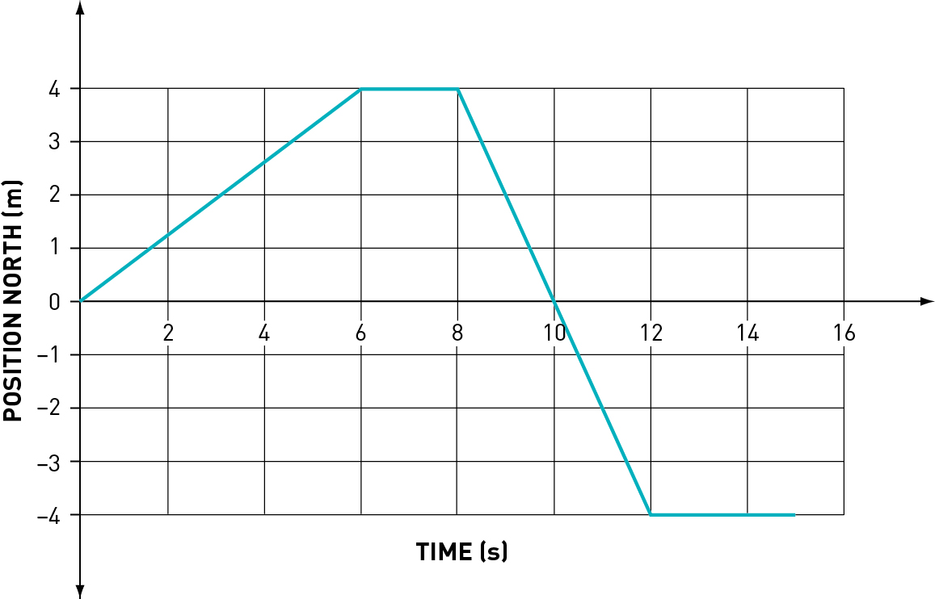

Figure 1

Discussion

1 How did your group perform in this task?

|  |
| --- |
|  |
|  |
|  |

2 What difficulties did you have in demonstrating the motion?

|  |
| --- |
|  |
|  |
|  |

3 Draw your own position–time graph and try to act out the motion. How did you go this time?

|  |
| --- |
|  |

Experiment worksheet

7.2 Velocity is speed with direction

Pages 158–159 and 220

Experiment 7.2A: The ticker timer

Aim

To learn how a ticker timer operates and to use it to produce a speed–time graph.

Materials

• Ticker timer

• Scissors

• Power supply

• Graph paper

• 2 electrical wires

• Glue

• Ticker tape

• Carbon circles

• Ruler

Method

1 Connect the ticker timer to the AC terminals of the power supply using the two electrical wires.



Figure 1

2 Thread a 30 cm length of ticker tape through the slots in the ticker timer. Turn on the power and pull the tape through the timer. Examine the tape to see if the dots are clear (Figure 2).

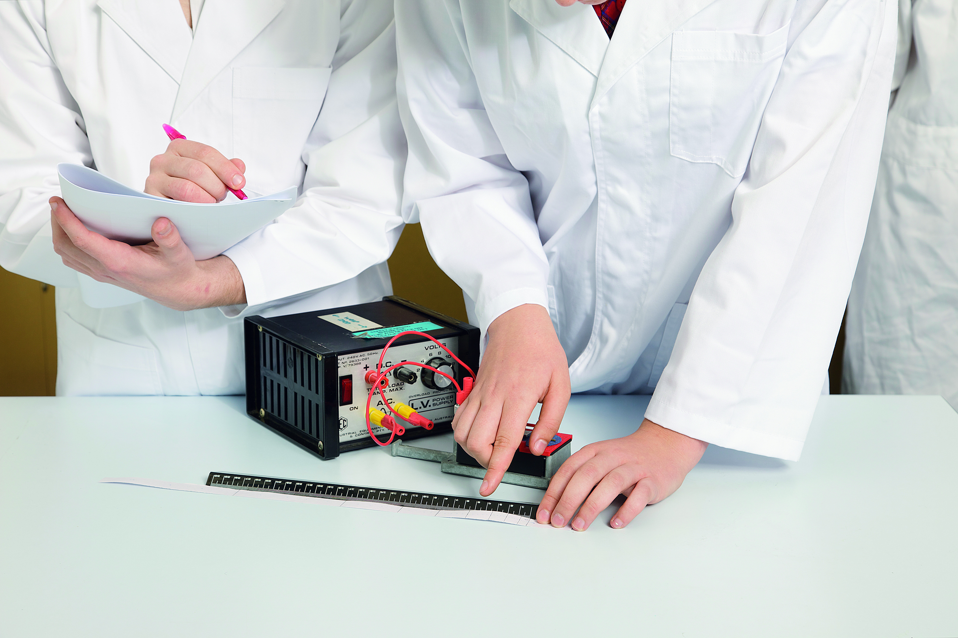

Figure 2

3 If the dots are too faint, adjust the equipment by increasing the voltage of the power supply. A new carbon disc may be required if this doesn’t solve the problem. It can also help to loosen or tighten the screw holding the ‘arm’ of the ticker timer.

4 Repeat with a 1 m length of ticker tape. As you pull the ticker tape through, adjust your pulling speed so that there is a very slow section, a medium speed section and a very fast section, in any order.

Results

1 Start your analysis by finding the first clear dot. Number this dot ‘0’. Count along another five dots and rule a line right through the middle of the fifth dot. This gives a five-’gap’ section of tape. The gap between successive dots is 0.02 seconds, so five gaps equals 5 × 0.02 or 0.1 seconds.

2 Divide the rest of your tape into five-gap sections by ruling lines through the middle of every fifth dot.

3 Number the sections of your tape and cut along the lines.

4 Glue each section of tape onto your graph paper, side by side, to form a column graph.

5 Add axes to your graph (speed on the y-axis and time on the x-axis) and work out a scale for each axis (see the hint below).

Discussion

1 Why does the length of each tape column indicate the speed?

|  |
| --- |
|  |
|  |
|  |
|  |

2 How could you work out the average speed of each section?  
(Hint: Average speed + distance ÷ time)

|  |
| --- |
|  |
|  |
|  |

3 Why is it only the ‘average’ speed?

|  |
| --- |
|  |
|  |
|  |
|  |

4 Design another experiment you could do using a ticker timer. Ask your teacher for permission to carry out your experiment.

|  |
| --- |
|  |
|  |
|  |
|  |

Conclusion

What information can you determine using a ticker timer?

|  |
| --- |
|  |
|  |
|  |
|  |

Experiment worksheet

7.2 Velocity is speed with direction

Pages 158–159 and 221

Experiment 7.2B: Using a motion sensor

Aim

To become familiar with the operation of a motion sensor and to use it to produce motion graphs.

Materials

• Motion sensor

• Dynamics trolley

• Laptop computer

Method

1 Connect the laptop to the motion sensor and open the appropriate software for your motion sensor on the laptop.

2 Position the motion sensor several metres in front of the dynamics trolley and push the trolley towards the sensor. (You may need to attach a cardboard reflector to the front of the trolley to reflect the signal from the motion sensor back to the sensor.) Ensure the trolley does not contact the motion sensor.

Results

Analyse the data on the laptop to produce a position–time graph (and speed–time graph and even an acceleration–time graph if possible).

Discussion

1 Can you work out what each graph is showing you?

|  |
| --- |
|  |
|  |
|  |
|  |
|  |

2 How well did the graphs represent the actual motion of the trolley that you witnessed?

|  |
| --- |
|  |
|  |
|  |

3 Design another experiment you could perform with the motion sensor.

|  |
| --- |
|  |
|  |
|  |
|  |

4 Evaluate this experiment compared with Experiment 7.2A in which you used the ticker timer. Which measuring instrument did you prefer and why?

|  |
| --- |
|  |
|  |
|  |
|  |

Conclusion

What information do the graphs created by a motion sensor tell you?

|  |
| --- |
|  |
|  |
|  |
|  |

Experiment worksheet

7.3 Acceleration is change in velocity over time

Pages 160–161 and 221

Challenge 7.3: Measuring acceleration by timing or using a motion sensor

Never drop objects from high places without looking below to make sure the area is clear. Never drop objects off buildings or bridges.

What you need

• Ball

• Stopwatch

• Tape measure

• Motion sensor

What to do

1 Measure how long it takes to drop a ball from one storey in seconds (t).

2 Measure the distance the ball fell in metres (h).

3 For more accuracy, or as a comparison, you could use a motion sensor connected to a computer to measure the acceleration directly.

4 Use the results to determine the acceleration due to gravity in units of m/s2. The formula that describes this situation is: h =  at2

5 Rearrange the formula to make a (acceleration) the subject and substitute your values for h and t. The resulting value for a is the acceleration due to gravity (although it usually has the symbol g), which should be 9.8 m/s2 near the Earth’s surface, although we often round it off to 10 m/s2 for calculations.

• How close to 9.8 m/s2 were your results?

• Can you account for any differences?

6 Challenge: You may like to make several different measurements and plot them as an h–t2 graph on your calculator. If you do a regression fit to the data, the gradient is h/t2, which is g. Double the gradient to get an average value for g.

Experiment worksheet

7.4 An object in motion remains in motion until a force acts on it

Pages 162–163 and 222

Challenge 7.4A: Make an accelerometer

What you need

• Small glass jar and lid

• Paperclip

• Short length of cotton

• Sticky tape

What to do

1 Tie one end of the cotton to the paperclip.

2 Stick the other end of the cotton to the underside of the lid so the paperclip hangs vertically inside the jar without touching the bottom.

3 Fill the jar with water and screw the lid on.

4 Test your accelerometer by pushing it slowly along a table, then speed it up, move it at constant speed and finally slow it down.

5 Take your accelerometer with you in the car, bus or train and observe the position of the cotton and paperclip when the vehicle:

• starts moving

• slows its movement

• travels at constant speed in a straight line.

Discussion

1 Why does the paperclip resist moving when the jar starts moving?

|  |
| --- |
|  |
|  |
|  |
|  |

2 Why does the paperclip keep moving forwards when the jar comes to a rest?

|  |
| --- |
|  |
|  |
|  |
|  |

3 What happens to the paperclip when the jar is moving at a constant speed?

|  |
| --- |
|  |
|  |
|  |
|  |

4 How do our own bodies tell us we are accelerating, decelerating or travelling around a corner?

|  |
| --- |
|  |
|  |
|  |
|  |

Experiment worksheet

7.4 An object in motion remains in motion until a force acts on it

Pages 162–163 and 222

Challenge 7.4B: How do you like your eggs?

What you need

• 2 eggs in their shells – one fresh and one hard-boiled, but no indication of which is which (Note: Use half full water bottles if egg allergies are a concern.)

What to do

1 Spin both eggs on a flat surface.

2 Stop the eggs gently by placing your finger momentarily on top of the spinning egg, then release the egg by lifting your finger off it. Does it stay stopped or keep spinning?

Discussion

1 How does the egg’s motion after you release your finger help you to predict whether the egg is hard-boiled or fresh? Open the shells (over a rubbish bin or sink) to see if you are correct.

|  |
| --- |
|  |
|  |
|  |
|  |

2 Think about the inside of the egg and the motion of the shell and the egg itself while it is spinning. Think also of Newton’s first law. Describe what you did in terms of inertia.

|  |
| --- |
|  |
|  |
|  |
|  |

Experiment worksheet

7.5 Force equals mass × acceleration

Pages 164–165 and 223

Experiment 7.5A: Resultant forces

Aim

To investigate the addition of vectors using three spring balances.

Materials

• 3 spring balances (0–10 or 0–20 N are best)

• 2 rubber bands

• Graph paper

• Masking tape

Method

1 Test to see that each spring balance reads zero with no force exerted on its hook. (This is known as checking the ‘calibration’.) If not, adjust it so it does.

2 Tape a piece of graph paper to the bench and draw a large dot in the centre of the paper.

3 Tie one rubber band to the centre of the other to create three ‘loops’ with a knot in the centre.

4 Hook each spring balance onto the loops lying flat on the paper and position the knot so that it stays directly above the dot on the graph paper (Figure 1).

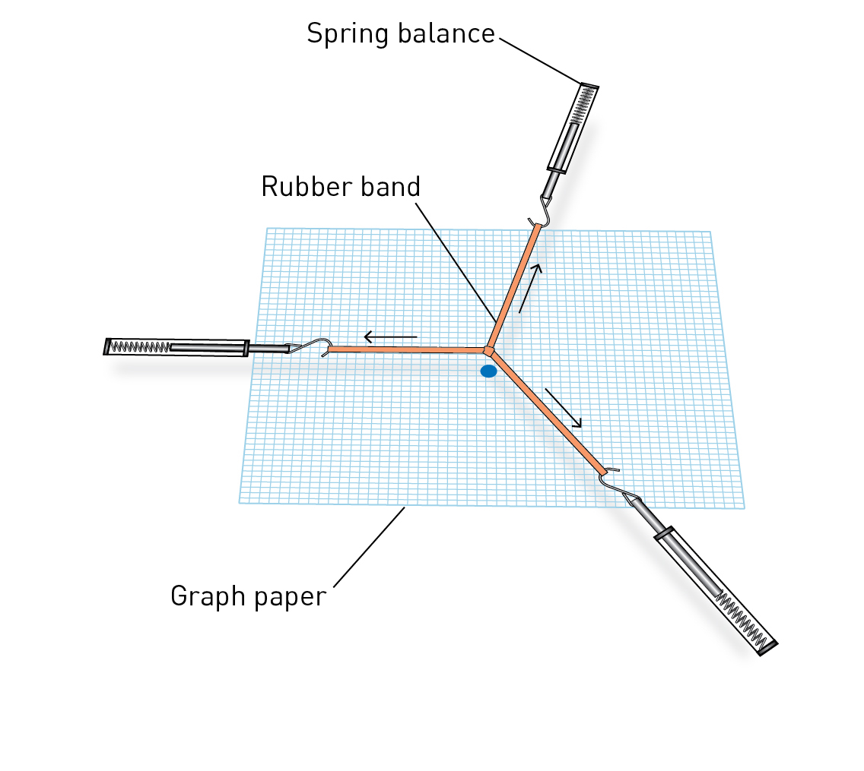

**Figure 1**

5 Pull on the spring balances in different directions so that the knot stays directly over the dot.

6 Record the force reading on each spring balance and draw the direction of the force on the graph paper. This can be done by drawing a line directly below the rubber bands.

7 Repeat the experiment twice more using different-sized forces and different directions.

Results

1 Drawing a force diagram: Remove the graph paper and create a force diagram by choosing an appropriate scale (usually 1 cm  1 N) and drawing the three forces acting from the dot in the correct directions. The forces are drawn as lines with arrowheads. The direction of the arrowhead shows the direction of the force. The length of each line should show the size of each force.

2 Drawing a vector diagram: To convert the force diagram into a vector diagram, leave one of the force arrows in position where it is, then ‘slide’ the other two force arrows so that all three join head to tail with each other. When all three forces are added, determine the net force by drawing a line from the start to the end and head-to-head and tail-to-tail. This shows the result of the three individual vectors, which should be very small or even non-existent if you did the experiment correctly.

Discussion

1 What is the difference between a force diagram and a vector diagram?

|  |
| --- |
|  |
|  |
|  |

2 What does ‘net force’ mean?

|  |
| --- |
|  |
|  |
|  |

Conclusion

What is the net force on a stationary object? Explain.

|  |
| --- |
|  |
|  |
|  |
|  |

Experiment worksheet

7.5 Force equals mass × acceleration

Pages 164–165 and 224

Experiment 7.5B: Accelerating masses

Aim

To determine the relationship between mass and acceleration.

Materials

• Dynamics trolley

• String

• Mass hanger and brass 50 g masses

• Several 1 kg masses

• Desk-mountable pulley wheel with clamp

• Electronic balance

• Motion sensor or stopwatch

• Tape measure or ticker timer

• Power supply

• Ticker tape

• Cushioning material

Method

1 Clamp the pulley wheel to the edge of the desk. Try to arrange the largest height above the floor as possible (Figure 1).



Figure 1

2 Attach one end of the string to the dynamics trolley and the other end to the mass hanger, carrying a total of approximately 200 g of mass (Figure 2).



Figure 2

3 Hang the masses over the pulley so they can pull the trolley along as they fall to the floor. Place the cushioning material under the weights to reduce impact.

4 Record the motion of the trolley as the masses fall, by using a motion sensor, timing with a stopwatch or recording the motion on ticker tape (Figure 3).

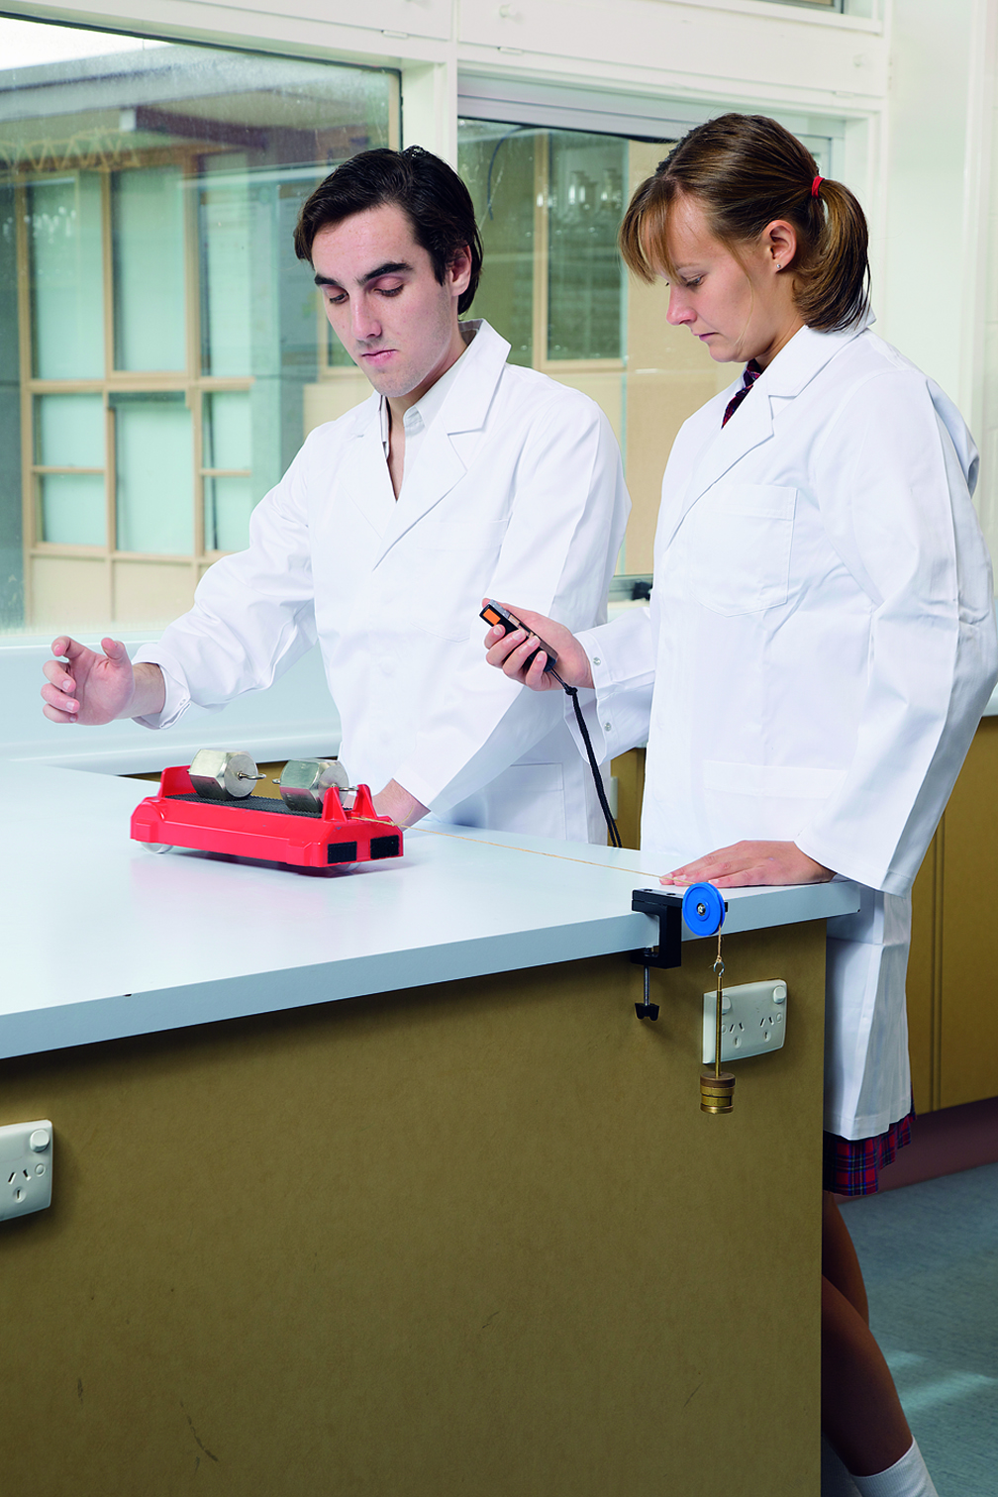

Figure 3

5 Successively add 1 kg masses to the trolley and repeat your measurements several times.

Results

1 Determine the acceleration of the trolley for your method.

2 If you used a motion sensor, use software (see Experiment 7.2B) to determine the acceleration directly or from the gradient of a velocity–time graph.

3 If you used a stopwatch, calculate the acceleration as (2 × the distance travelled ÷ time squared).

4 If you used a ticker timer, use the ‘every fifth dot method’ as per Experiment 7.2A to divide the tape into sections. Determine the speed of each section by dividing the distance covered by 0.1. Plot a speed–time graph and determine the acceleration from the gradient of the graph.

5 Plot a graph of acceleration versus total mass. This should give a truncated, or inverse, graph.

Discussion

1 How did increasing the mass on the trolley affect the acceleration of the trolley?

|  |
| --- |
|  |
|  |
|  |

2 Relate your experiment to a real-life example.

|  |
| --- |
|  |
|  |
|  |
|  |

Conclusion

What is the relationship between mass and acceleration?

|  |
| --- |
|  |
|  |
|  |
|  |
|  |

Experiment worksheet

7.6 Each action has an equal and opposite reaction

Pages 166–167 and 225

Experiment 7.6: Newton’s rocket

Aim

To examine the action and reaction of a balloon rocket.

Materials

• Balloon

• Drinking straw

• Sticky tape

• Fishing line

• Timer

• Measuring tape

Method

1 Thread the fishing line through the straw.

2 Tie the ends of the fishing line to two fixed points across the room.

3 Inflate the balloon and hold it shut. Measure the diameter of the balloon.

4 Use the sticky tape to tape the inflated balloon to the straw.

5 Release the end of the balloon and measure the distance the balloon travels and the time it takes to come to a complete stop.

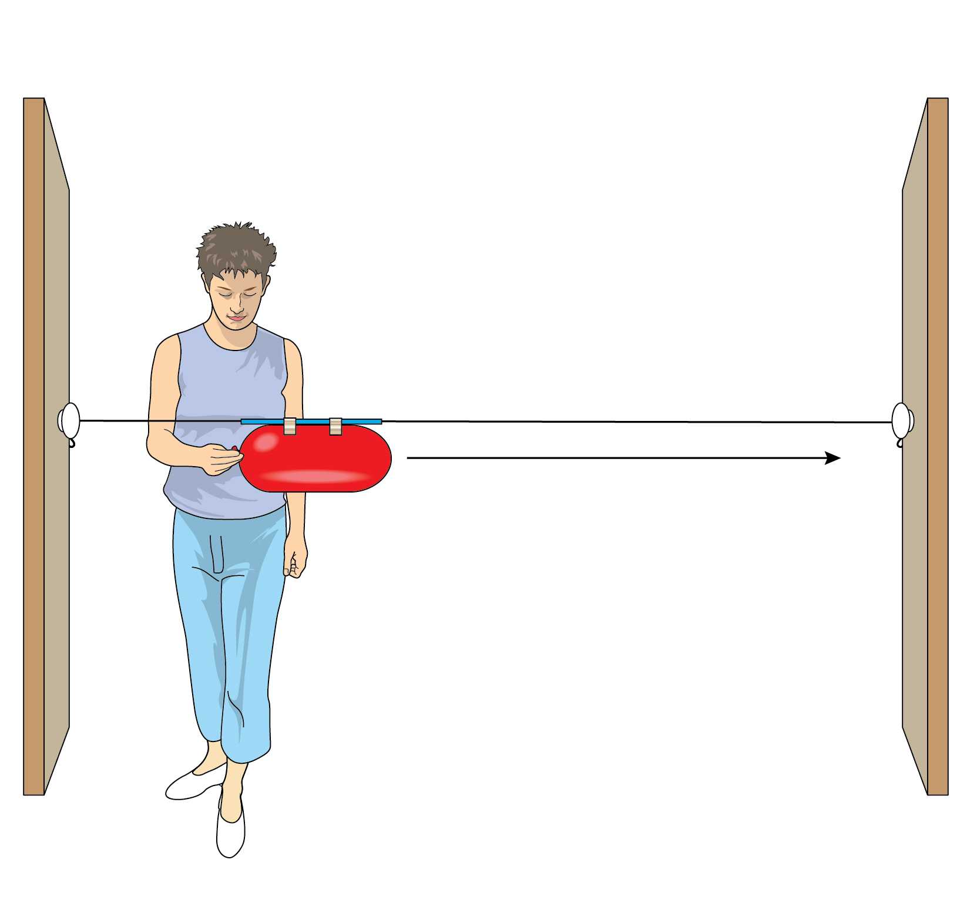

6 Reinflate the balloon to the same diameter. Repeat step 5.

7 Determine the average speed of the balloon.

Results

8 Record your results in an appropriate table.

|  |
| --- |
|  |

Discussion

1 Why does the balloon move forwards?

|  |
| --- |
|  |
|  |

2 Draw a picture of the balloon rocket with all the forces that are acting on it.

|  |
| --- |
|  |
|  |

3 Describe the action and reaction that occurs in the balloon rocket.

|  |
| --- |
|  |
|  |

4 How would you expect the average speed to change if the balloon was inflated less? Explain.

|  |
| --- |
|  |
|  |

Conclusion

Describe how Newton’s third law applies to your balloon rocket.

|  |
| --- |
|  |
|  |
|  |
|  |

Experiment worksheet

7.7 Momentum is conserved in a collision

Pages 168–169 and 226

Experiment 7.7: Colliding trolleys

Aim

To investigate whether total momentum is conserved during a collision.

Materials

• 2 dynamics trolleys

• Metre ruler

• Ruler

• Several 1 kg masses to add to the trolleys

• 2 rubber bands tied together that will stretch to 20 cm quite easily

• Level benchtop

• Piece of A4 paper

• Masking tape

Method

1 Attach the piece of A4 paper to the benchtop with masking tape. Rule two parallel lines on the paper, 20 cm apart (Figure 1).

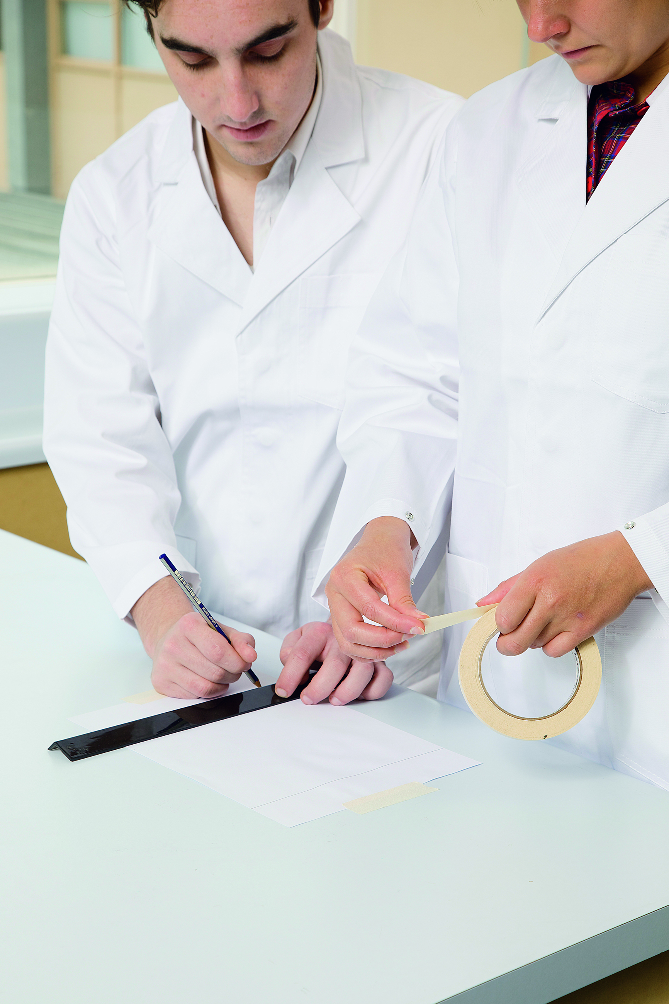

Figure 1

2 Link the two trolleys with the rubber bands (Figure 2).



Figure 2

3 Pull the trolleys apart and hold them with their front ends on the two lines (Figure 3).

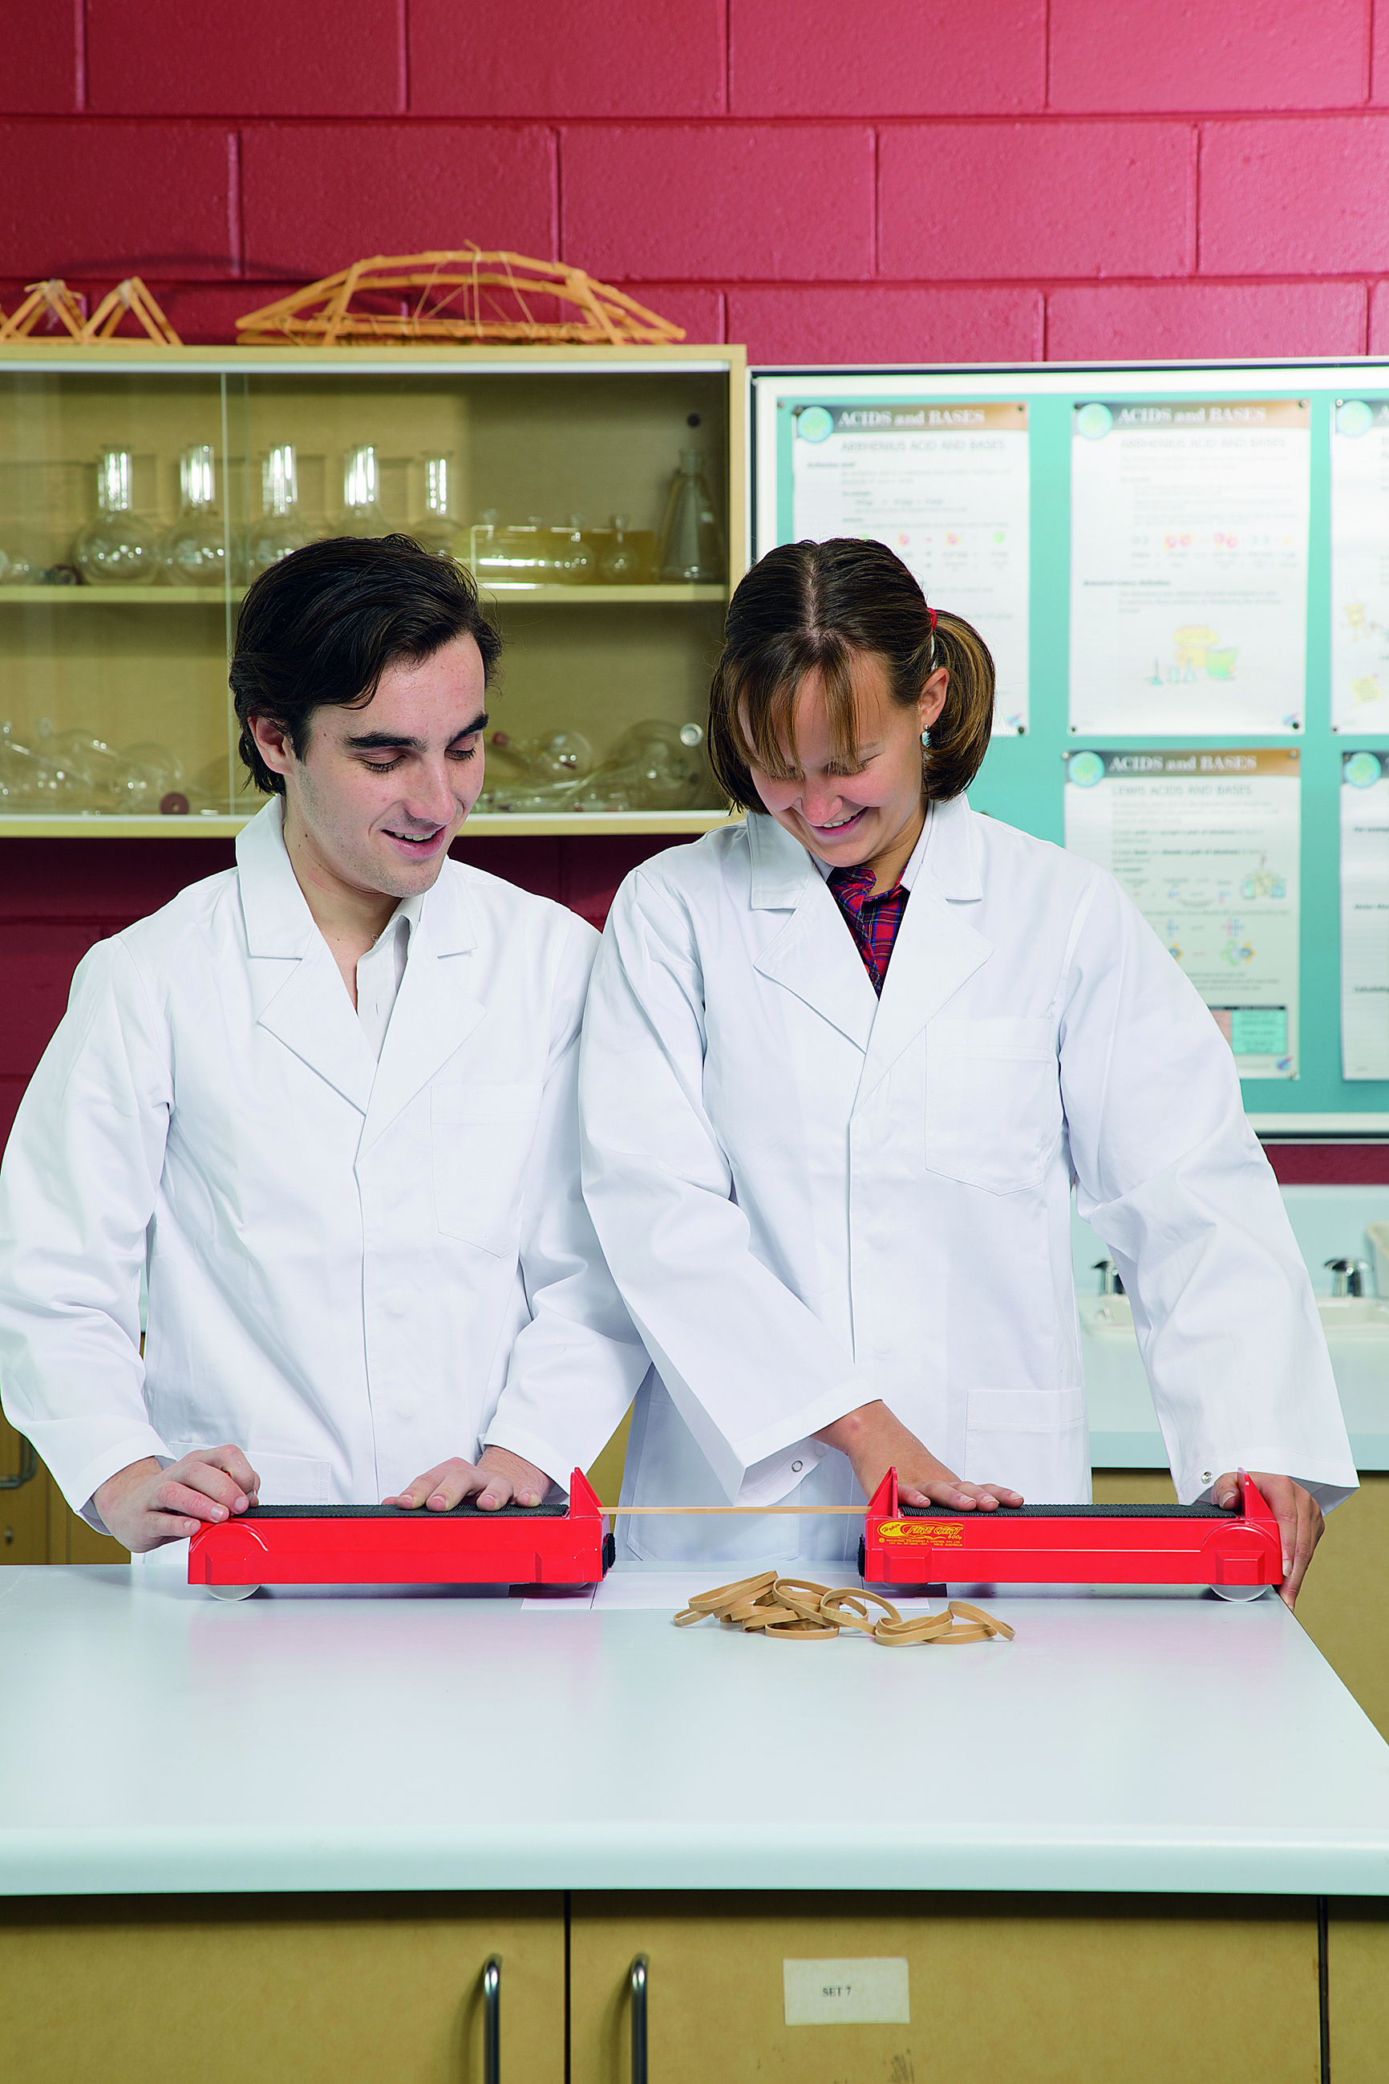

Figure 3

4 Release the trolleys. The trolleys will accelerate towards each other and collide at the same time. How far the trolleys travel in a given time is proportional to their relative velocities. Determine where the trolleys collide and mark the collision point on the paper.

5 Measure the distance from one line to the collision point (d1) and the same for the other line (d2). Because the trolleys collide at the same time, there is no need to measure the times because the distances are proportional to the collision speeds.

6 Add various masses to one (or both) of the trolleys and repeat the experiment. Test approximately five different mass combinations.

Results

Record the following result headings in a spreadsheet or table.

• m1 = mass of trolley 1 plus any 1 kg masses added (total in kg)

• d1 (in m)

• m1 × d1

• m2 = mass of trolley 2 plus any 1 kg masses added (total in kg)

• d2 (in m)

• m2 × d2

• (m1 × d1) – (m2 × d2)

The final column gives a measure of the total momentum of the two trolleys just prior to the collision. The negative sign is used because the two trolleys are travelling in opposite directions and therefore one momentum is negative.

Discussion

1 When the trolleys are released, do they travel towards each other for the same period of time? Explain.

|  |
| --- |
|  |
|  |
|  |
|  |
|  |

2 Is the magnitude of the force acting on each trolley the same? Explain.

|  |
| --- |
|  |
|  |
|  |
|  |
|  |
|  |

3 If both trolleys come to a stop after the collision, what was the final total momentum of the ‘system’? Explain.

|  |
| --- |
|  |
|  |
|  |
|  |
|  |

4 According to the last column of results, what was the initial total momentum of the ‘system’?

|  |
| --- |
|  |
|  |
|  |
|  |

Conclusion

What did this experiment demonstrate about the total momentum before and after a collision?

|  |
| --- |
|  |
|  |
|  |
|  |
|  |
|  |

Experiment worksheet

7.8 Work occurs when an object is moved or rearranged. Energy can be calculated.

Pages 170–171 and 227

Experiment 7.8: What if an elastic band was stretched further?

Aim

To determine the relationship between the elastic potential energy and kinetic energy of an elastic band.

Materials

• Metre ruler

• Elastic bands

• Tape measure

• Chalk



CAUTION: Wear safety glasses at all times to prevent eye injuries.

Method

1 Use the chalk to place a mark on the ground. This is the starting point for your elastic band.

2 Hook one edge of the elastic band on the end of the ruler. Pull the rubber band back to the 10 cm mark on the ruler and let it go.

3 Measure the distance the elastic band moved.

4 Repeat steps 2 and 3 another three times (remembering the angle and height needs to be consistent with the first attempt) and average the distance the elastic band travelled.

5 Use the spring balance to determine the amount of force (N) needed to stretch the elastic band 10 cm.

Inquiry

1 What is the independent variable?

2 What is the dependent variable?

3 List three variables you will need to control and how you will control them.

4 Write a hypothesis for your experiment.

5 Explain the science behind your hypothesis.

Results

1 Draw an appropriate table for your experiment.

|  |
| --- |
|  |

2 Draw a graph of the distance the elastic band was stretched against the distance the elastic band moved.

|  |
| --- |
|  |

3 If the F = kx where F is the force needed to stretch the rubber band 10 cm (as measured by the spring balance) and x is 0.1 m, then what is k, the elastic constant for your elastic band?

|  |
| --- |
|  |

4 Use the elastic constant you measured in step 3 to determine the amount of energy in the elastic band when you stretched it 10 cm. Remember to convert the cm into m.

|  |
| --- |
|  |

Discussion

1 Describe the relationship between the distance the elastic band was stretched and the distance the elastic band moved.

|  |
| --- |
|  |
|  |

2 Where did the initial energy come from to stretch the elastic band?

|  |
| --- |
|  |
|  |

3 What type of energy did the elastic band have?

|  |
| --- |
|  |
|  |

4 How much work was done when the elastic band was first stretched? (W = Fd)

|  |
| --- |
|  |
|  |

5 If all the elastic potential energy was translated to kinetic energy, how much kinetic energy did the elastic band have when it left the ruler?

|  |
| --- |
|  |
|  |

6 What velocity did the elastic band have when it left the ruler? (KE = mv2)

|  |
| --- |
|  |

Conclusion

What do you know about the energy in an elastic band?

|  |
| --- |
|  |
|  |
|  |

Experiment worksheet

7.9 Energy is always conserved

Pages 172–173 and 228

Challenge 7.9: Conservation in action

Analysis of a simple pendulum shows that it follows a similar pattern to dropping a mass.

What you need

• Simple pendulum made from a mass on the end of a length of string

• Retort stand

What to do

1 Hang the simple pendulum from the retort stand (Figure 1).



Figure 1

2 Lift up the mass and release it. As it swings, its GPE is converted into KE and back into GPE. The process continues until the pendulum finally comes to rest.

3 Measure how much GPE the pendulum mass had at the start before it was released by measuring its mass and starting height above the bench and using the GPE formula.

4 Allow the pendulum to complete 10 full swings (the release point is swing 0) and stop it at the end of its 10th swing. Hold the weight at the finishing height.

5 Measure the finishing height and determine how much energy was ‘lost’ to air friction each swing (divide by 10 swings).

6 Work out the energy efficiency of the pendulum. Set out your calculations clearly and accurately.

|  |
| --- |
|  |